1. **Main scenario**

|  |  |  |  |  |  |  |  |  |  |  |  |  |  |
| --- | --- | --- | --- | --- | --- | --- | --- | --- | --- | --- | --- | --- | --- |
| |  |  | | --- | --- | | **Use Case** | **Main scenario** | | **Id** | 1 | | **Actors** | Testee, System | | **Pre-Conditions** | Lists of testees and questions are already introduced | | **Main Success Scenario** | 1. System select question 2. System send question to current testee 3. Testee get question 4. Testee answer 5. Testee send answer 6. System get answer 7. System add answer to history | | **Comment** |  | | Pic 1. Send answer |

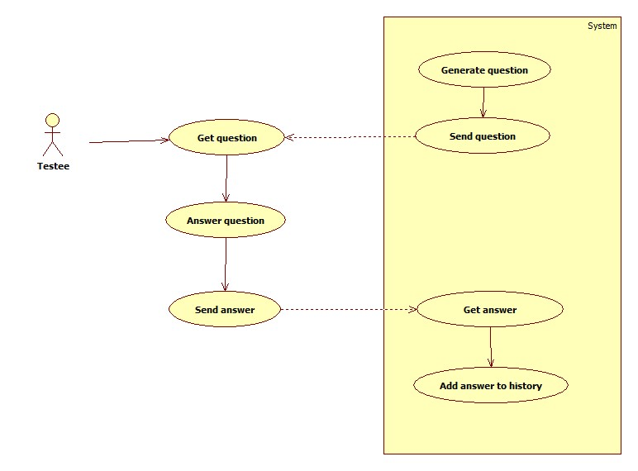

Pic 2. Main scenario diagram

1. **Setup**

**2.1 set up data**

**List of setup entities:**

1. List of testee users
2. List of training
3. List of questions with answers

|  |  |  |  |  |  |  |  |  |  |  |  |  |  |  |  |
| --- | --- | --- | --- | --- | --- | --- | --- | --- | --- | --- | --- | --- | --- | --- | --- |
| |  |  | | --- | --- | | **Use Case** | **Setup of data** | | **Id** | 2.1 | | **Actors** | Administrator, System | | **Pre-Conditions** |  | | **Main Success Scenario** | 1. Administrator inquires settings page 2. System opens settings page 3. Administrator inquires interface for loading information. 4. System provides an interface for importing data. 5. Administrator specifies the data source for import 6. System analyzes the incoming data. 7. System imports data 8. System announces the successful import of data | |  | 2а. Administrator enters data manually   1. Administrator inquires interface for adding information. 2. System provides an interface for adding data. 3. Administrator enters data and requests saving changes. 4. System saves data   5а. Parameters entered incorrectly  6. System displays a message about incorrectly filled fields.  7. System returns to the editing.  7a. Failed import  8. System displays a message about failed import. | |  |  | | Pic 3. Set up trainings    Pic 4.Add or edit trainings    Pic 5. Add or edit question    Pic 6. Set up testees    Pic 7. Add or edit testee |

**2.2 Edit data**

|  |  |  |  |  |  |  |  |  |  |  |  |  |  |
| --- | --- | --- | --- | --- | --- | --- | --- | --- | --- | --- | --- | --- | --- |
| |  |  | | --- | --- | | **Use Case** | **Edit data** | | **Id** | 2.2 | | **Actors** | Administrator, System | | **Pre-Conditions** | Some of the data already entered | | **Main Success Scenario** | 1. Administrator inquires settings page 2. System opens settings page 3. Administrator inquires interface for editing information. 4. System provides an interface for editing data. 5. Administrator edit data 6. Administrator enters data and requests saving changes. 7. System saves data | | **Comment** | 5а. Parameters entered incorrectly  6. System displays a message about incorrectly filled fields.  7. System returns to the editing. | |  |

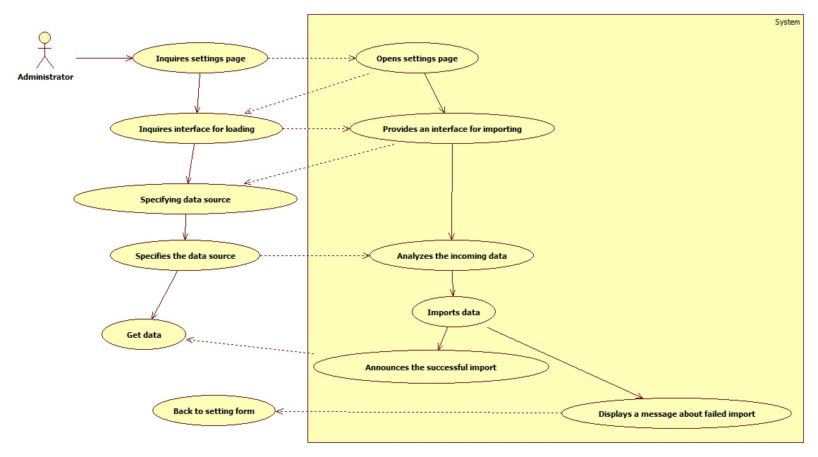

Pic 8. Importing data

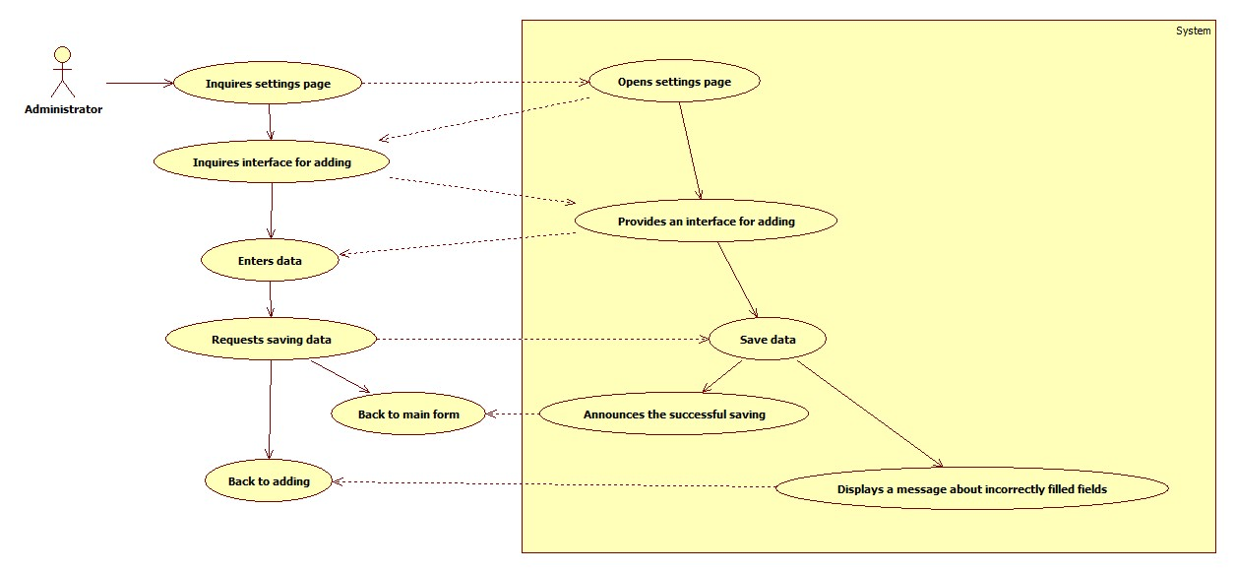

Pic 9. Manual adding

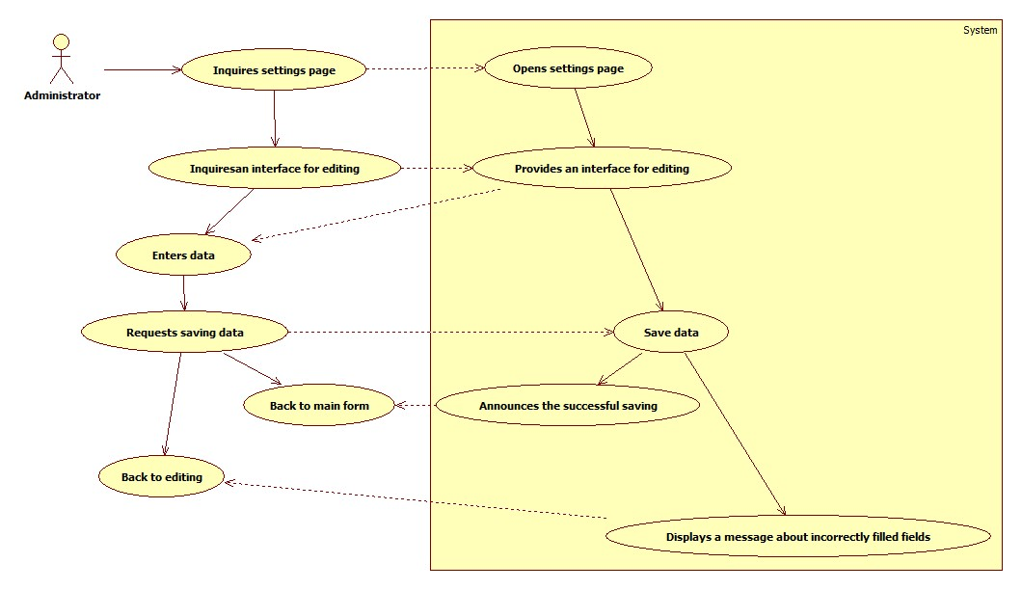

Pic 10. Editing

**2.3 Set up clients settings**

List of custom parameters

1. Frequency of asking questions and their amount

|  |  |  |  |  |  |  |  |  |  |  |  |  |  |  |  |
| --- | --- | --- | --- | --- | --- | --- | --- | --- | --- | --- | --- | --- | --- | --- | --- |
| |  |  | | --- | --- | | **Use Case** | **Setup user settings** | | **Id** | 2.3 | | **Actors** | Administrator, System | | **Pre-Conditions** |  | | **Main Success Scenario** | 1. Administrator inquires settings page 2. System opens settings page 3. Administrator enters data and requests saving changes. 4. System saves data | |  | 5а. Parameters entered incorrectly  6. System displays a message about incorrectly filled fields.  7. System returns to the editing. | |  |  | | Pic 11. Clients set up |

1. **Client setup**

List of custom parameters

1. Frequency of asking questions and their amount

|  |  |  |  |  |  |  |  |  |  |  |  |  |  |  |  |
| --- | --- | --- | --- | --- | --- | --- | --- | --- | --- | --- | --- | --- | --- | --- | --- |
| |  |  | | --- | --- | | **Use Case** | **Setup user settings** | | **Id** | 2.2 | | **Actors** | Testee, System | | **Pre-Conditions** |  | | **Main Success Scenario** | 1. Testee inquires settings page 2. System opens settings page 3. Testee enters data and requests saving changes. 4. System saves data | |  | 5а. Parameters entered incorrectly  5. System displays a message about incorrectly filled fields.  6. System returns to the editing. | |  |  | | Pic 12. Clients set up |

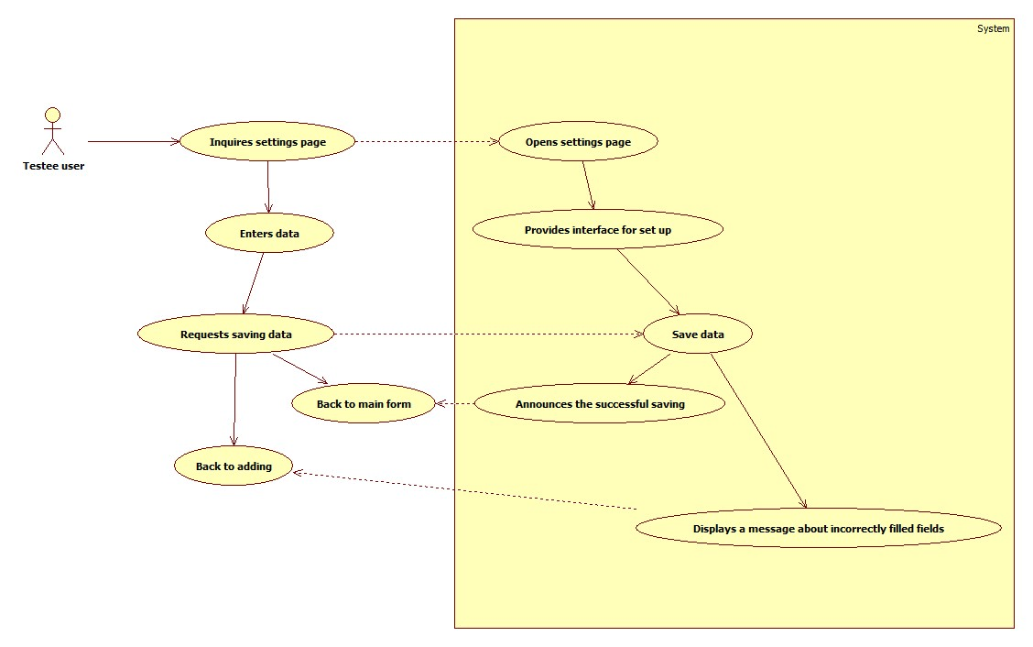

Pic 13. Clients set up diagram